**Online Test-Taking Tips**

1. Use the same variable as the question in your answer. Ex: cost (*C*), time (*t*) $C=75t+50$, NOT $y=75x+50$

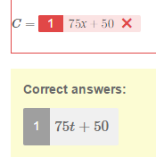

1. For -.75, type -0.75 or $\frac{3}{4}$
2. Always reduce. Ex: Not $\frac{4}{2}x+2$, but type $2x+2$

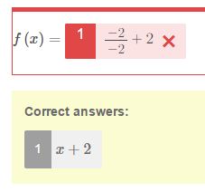

1. Double check what you typed. Ex: typed 3.81, but meant 3.91
2. Equations are right or wrong- Ex: no partial credit for slope and y-intercept

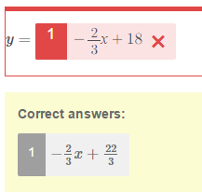

1. Don’t put y= if it is already there. Don’t put a $ if it is already there.

Ex: y= y=2x+5 or $ $340.80

1. Just because it makes a true statement doesn’t mean it makes sense in context and answers the question. Read EVERYTHING carefully.
2. Don’t forget “x” or a variable in $y=mx +b$ equations. Ex: meant $y=2x+7$, but put $y=2+7$

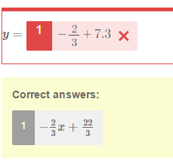

1. Don’t use Point-Slope Form $y-y_{1}=m(x-x_{1})$ if there is a y=

Either use $y=mx+b$ or $y=m\left(x-x_{1}\right)+y_{1}$

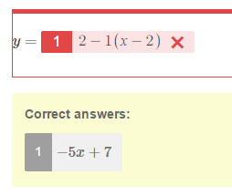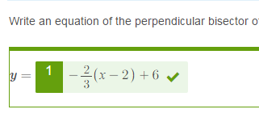

1. Don’t round repeating decimals. Write as an improper fraction.

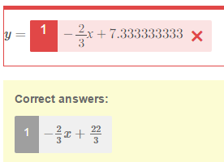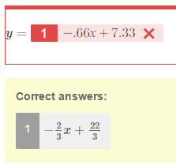

1. Don’t use the multiplication sign for the variable $x$.

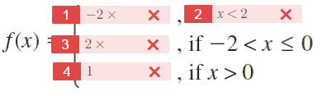

1. Actually work out the problem on paper or use the embedded calculator application.

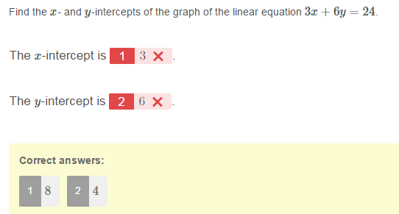

1. Know how to create fractions using the embedded application.

